Meppershall

Church of England
Academy

New Parent and Carers

Year 1- 4 Handbook
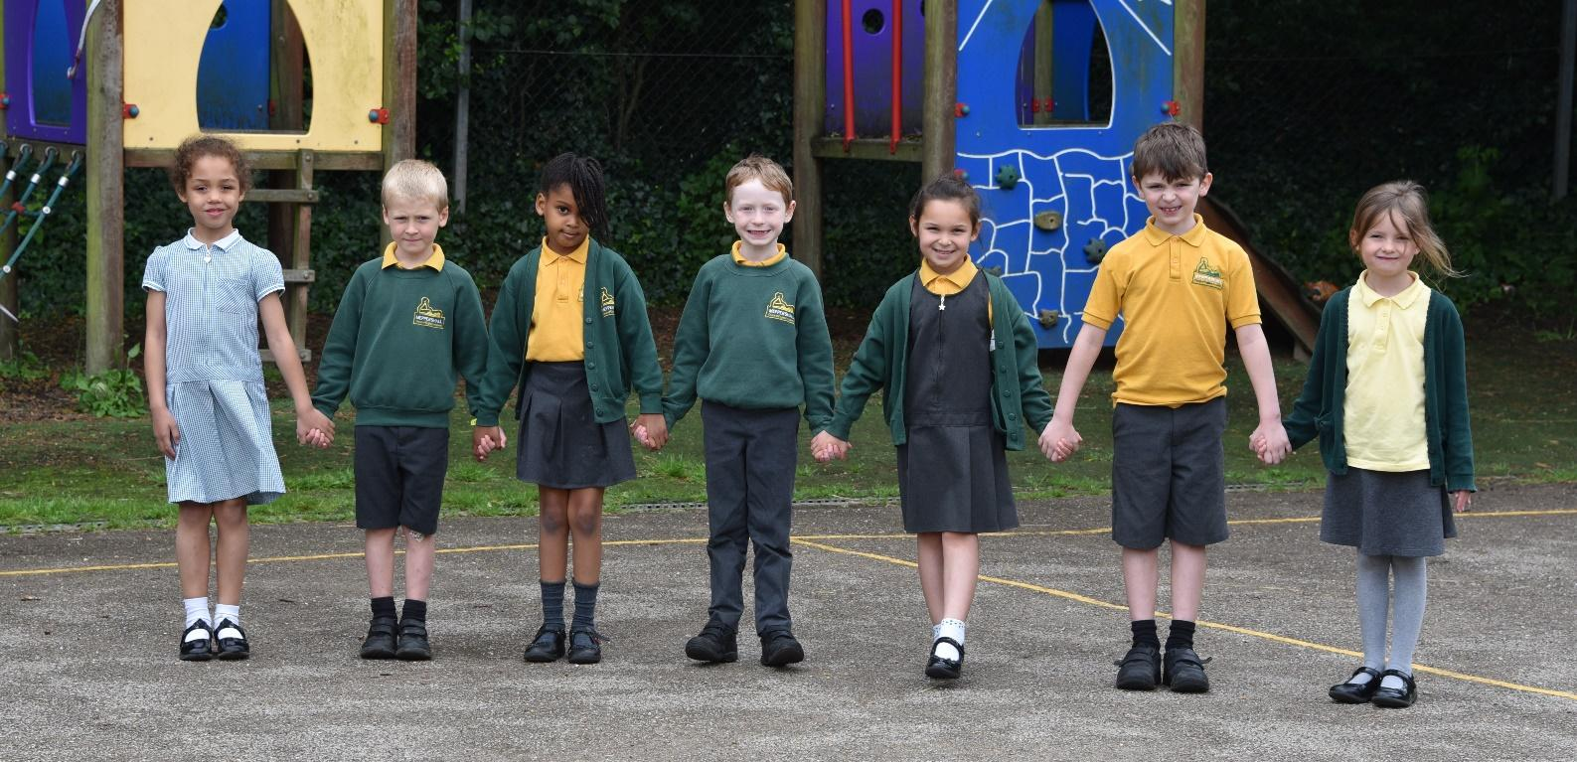

About Our School

Our school is a Church of England Academy for children aged 4 to 11 years and is very much part of the local community. It has strong connections with the local Church of St Mary’s, with regular visits from the Vicar, Revd. Roni Goodman. Our staff and Governing Body has strong Christian Representation.

Mission Statement

Love of God, Life, Learning and Each Other

Our Christian Vision

This is based on two texts from the Bible:

“I have come that you may have life in all its fullness.” (John 10:10)

“Start children off on the way they should go, and even when they are old they will not turn from it” (Proverbs 22:6).

At Meppershall Church of England Academy, we aim for academic and personal achievement through:
- helping each child to grow their own potential, in an environment of faith, creativity, aspiration, challenge and celebration;
- equipping each person to make their own unique contribution to the school, community, the wider world and the kingdom of God for the benefit of all.

What it means to belong to a ‘Church of England’ academy.

Our daily worship time is mostly based on Christian teachings. We celebrate Harvest, Christmas and Easter at services in St Mary’s Church, Meppershall. Parents/carers are invited to join us on these occasions. We also worship as a school at key times in the year e.g. Ash Wednesday, Pentecost and Trinity.

Each day all children have an act of Collective Worship. This may take place in their classroom or as a whole school community. Worship focuses on our values and is linked to Christian teachings and Bible stories. We also have a weekly celebration of effort, good, work and Christian values. Achievements out of school are also celebrated and children are encouraged to bring in medals, certificates etc. We take great joy in singing during our daily worship.

Class Organisation

Children are organised into year group classes.
Year group | Class name | Age | Phase
Reception | Acorns | 4-5 | EYFS (Early Years Foundation Stage)
Year 1 | Elms | 5-6 | KS1 (Key Stage 1)
Year 2 | Willows | 6-7 | KS1 (Key Stage 1)
Year 3 | Birches | 7-8 | KS2 (Key Stage 2)
Year 4 | Oaks | 8-9 | KS2 (Key Stage 2)
Year 5 | Based at Henlow Church of England Academy | 9-10 | KS2 (Key Stage 2)
Year 6 | Based at Henlow Church of England Academy | 10-11 | KS2 (Key Stage 2)

When the children leave us they start KS3 (Year 7) at secondary school. We are a feeder school to Henlow Church of England Academy.

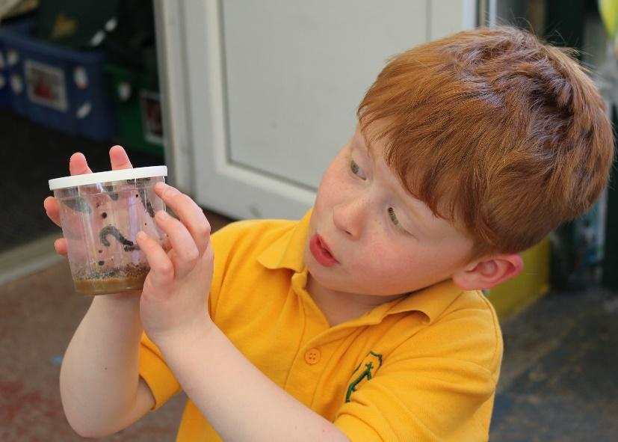
Behaviour in School

Our children behave well in school because we have high expectations of their behaviour. We have an agreed approach to managing any behaviour that results from children finding it difficult to make good choices. If a child’s behaviour does cause notable or persistent concern parents/carers will be informed so that we can work together to help your child. Bullying, in any form, is never tolerated.

Children with Special Educational Needs and Disabilities

We are an inclusive school and welcome children whatever their area of need. The arrangements for children with disabilities will be the same as those detailed in this brochure. Parents /Carers are warmly invited to visit the school. The school’s Equality Policy does not

allow discrimination for any member of the community on grounds of disability. The policies on anti-bullying and personal, social, health and citizenship education will reinforce this and confirm the clear intent of all members of the community that children with disabilities should be treated equally.

Emergency contact details

Before your child starts school, it is vital that we have the following information

• Names and full addresses of parents/carers (and confirmation of parental responsibility)

• Home, mobile and work telephone numbers

• phone numbers of two emergency contacts who may be called in the event of parents/carers being unobtainable especially in the case of an emergency.

Again, it is vital that you inform us immediately if there is any change to this information as we may need to contact you urgently in case of emergency.

We will ask you to check and update this information annually.

Absence

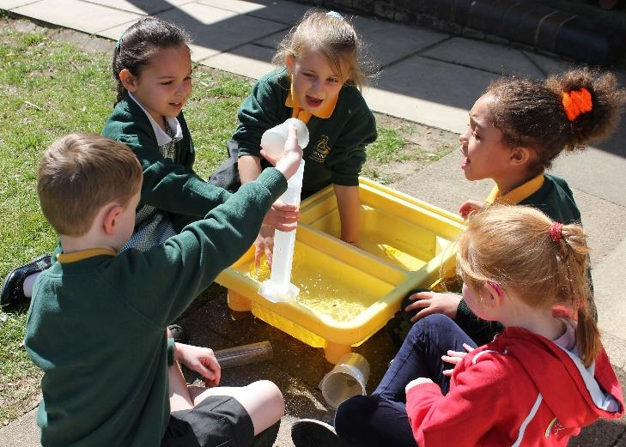
To ensure children’s safety, and to help us meet Government guidelines, we request that if your child is unwell you contact the school office, before 9.00am to inform us of your child’s absence. In cases where parents/carers have been unable to do this, we endeavour to contact parents/carers ourselves. In this way we will have the greatest possible confidence that children are either safely at school or safely with their parents/carers. Failing any other contact please send a letter on the child’s return indicating the reason for absence.

Medicines in School

Staff are not permitted to administer any medication not prescribed by the doctor. If your child has to be given prescribed medicine, you must go to the school office to complete an authorisation to administer medicine form. Medicine can only be administered if the doctor has prescribed 4 or more doses to be administered in 24 hours. 3 doses will need to be administered at home (before school, after school and at bedtime). Under no circumstances must children bring in any form of medication to school and have it in their book bag. All medicine must be kept in the school office or as required in the staffroom fridge.

If your child uses an inhaler, please inform the school and complete a medical plan, so that the school is fully aware of any emergency procedures, along with the use and storage of inhalers.

Accidents and Sickness during the school day

We may need to contact you urgently in the case of illness or accident. Please ensure that the school always has an up-to-date emergency contact number for you and the details of other adults we can contact in an emergency.

If your child has a serious accident whilst at school you will be informed immediately and, if necessary, arrangements will be made to take the child to hospital. In cases of sickness, parents/carers or the named person are notified and asked to collect the child. If a child has sickness and/or diarrhoea whether at home or at school, it is school policy that the child does not return to school within 48 hours to minimise the risk of spreading the illness in school.

Children with Allergies (particularly a nut allergy)

Please inform the class teacher and school office in writing if your child suffers from any allergies and the action to be taken as appropriate. It is the parent/carers’ responsibility to ensure medication in school is kept up to date.

Children with Asthma

Parents/carers are asked to supply the school with full information concerning the severity of the illness and to ensure that a usable inhaler is always available during school hours.

Head Lice

Head lice continue to be a common occurrence in schools. Cleanliness is no barrier and they can quickly spread if appropriate action is not taken. The daily use of a fine-toothed comb on damp, well-conditioned hair is the best safeguard. Girl’s hair is best tied back or plaited. Please check your child’s hair on a regular basis. If you suspect that your child has them, please notify the school so that we can alert other parents/carers.

Appointments in the school day

We ask you to avoid making appointments for your child during the school day as it disrupts learning, but we also recognise that on occasions this is unavoidable. If your child needs to be taken out of school for any reason during the school day, please notify the school in advance. Your child will need to be signed out at the school office and sign in on their return to school after their appointment. This will ensure the safety of your child at all times.

In keeping with Government policy, unless circumstances meet certain exceptional criteria and evidence is provided by the parent, any absence from school will not be authorised.

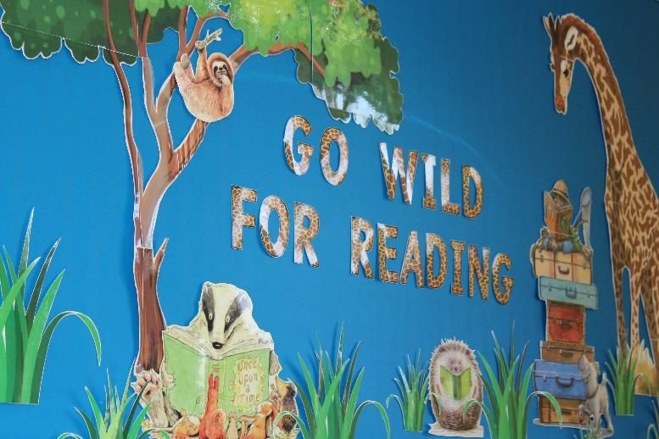
Holidays in Term Time

Information for Parents/Carers: A significant amount of school time is lost each year as a result of parents/carers taking their children out of school in order to go on family holidays. Schools have a duty of care to reduce the amount of time lost in this way and have developed school policies and procedures to enable them to achieve this.

What the law says: As a parent you do not have any legal right or entitlement to take your child out of school in order to go on a family holiday during term-time and you should not as a rule expect any leave requested to be authorised.

The regulations state that headteachers may only grant any leave of absence during term time if there are exceptional circumstances.

If you request leave you must be able to demonstrate that the circumstances are exceptional. Schools will not as a rule consider the following to be exceptional circumstances:

•the availability of cheap holidays;

•the availability of the desired accommodation;

•poor weather experienced during school holiday periods;

•an overlap with the beginning/end of term;

•you have not previously requested term-time leave.

If you take your child out of school for a family holiday without the school’s prior authorisation the absence will be recorded as unauthorised and noted in your child’s school records. Similarly, if your child goes on a family holiday which has been authorised by the school yet fails to return by the agreed date any extra time absent from school will be counted as unauthorised. If your child fails to return within 10 days of the expected date of return, then the school may remove your child from the school role and notify the council accordingly.

If your child is absent from school on a family holiday without authorisation the school may ask the council to serve a Penalty Notice. This Penalty Notice is a fine of £60 per parent per child which, if not paid within 21 days, rises to £120.

The School Day for children in KS1 and KS2

The timings of the day are:

8:40am Gates open for access to playground. Please stay with your child

8:45am Classroom door opens – feel free to speak to the class teacher**

8:55am Registration

9:00 - 10:30am Lesson Time

10:30 - 10:45am Worship Time

10.45 – 11:00am Playtime

11:30 – 12.15pm Lesson Time

12:15 - 1:15pm Lunchtime

1:15pm Register

1:20pm Lesson Time

3:15pm Gates open for Parents/Carers to collect their children from the classroom door at 3.30pm

**Parents/Carers are welcome to speak briefly to the teacher at the start and end of the school day. If a longer conversation is needed, the class teacher may suggest that you make an appointment at a mutually convenient time.

Wrap Around Care

The school offers before and after school care. Breakfast Club runs from 8am at a cost of £4.00 and after school we have two sessions, 3:30 pm - 4:30pm £4.00 and 4:30pm until 5:30pm £5.00. This can be booked weekly or on an ad hoc basis with the office.

Arrangements for end of the day: our safeguarding procedures

Your child’s safety is paramount and we do our utmost to keep them safe in school. Collection arrangements are very important and it is our responsibility to make sure your child goes home with a trusted adult authorised by you.

Your child will be ready to be collected at 3.15pm. Please let us know the names of adults who will be collecting your child on a regular basis.

Going Home with another adult

If your child is going home with anyone other than yourself, on a one-off basis, you MUST fill out an End of School Day Collection slip. These can be collected from the school office. Alternatively,

please contact the school office before 3pm if possible. In the case of an emergency (e.g. if you are delayed or held up by traffic) it is vital you make every effort to contact the school office.

If someone comes to collect your child and we do not have prior authorisation from you, we will not allow your child to leave with them until we have made contact with you and had authorisation from you to let your child go with them.

Children left at school at the end of the day

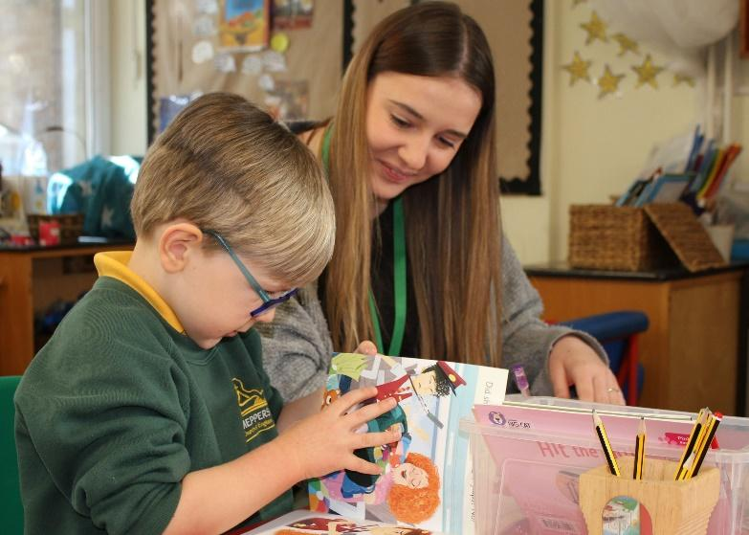
Please see our Late Collection Policy which can be found on our website.

We have a statutory duty to safeguard and promote the welfare of children, and that duty extends to having arrangements in place for dealing with children who are not collected at the end of a school day, or at the end of an authorised activity.

It is the parent/carer’s responsibility to ensure that the pupil is collected by a responsible person. The school must be notified immediately it becomes apparent that the person collecting the child may be late.

Collection by taxi service

If you have made fixed daily arrangements to have your child collected by taxi it is important we know if there are any changes to these arrangements. Please leave a message with the school office if you need to make any such changes.

Uniform

School uniform can now be purchased from PrestigeDesign and Workwear.

Please order online at www.prestigedesignww.co.uk Alternatively you can phone Prestige on 01525 716558.

Orders will be delivered to the school free of charge; alternatively, if you wish for your items to be delivered to your home this will incur a cost.

School Uniform PE Kit

Yellow polo shirt Yellow PE top

Bottle green sweatshirt / cardigan Black PE shorts

Grey trousers/shorts PE bag

Grey skirt / grey pinafore/green gingham summer dress Trainers for outdoors

Black school shoes – worn all year round Black tracksuit

Book bag

Water bottle

Please ensure that all items are clearly named.

Jewellery & Accessories

Due to health and safety children should not wear jewellery of any kind and no apple watches.

PE and Games kit: Please NAME ALL ITEMS.

We place great importance on children’s Physical Education. We aim to ensure that all children experience a range of sports and games to develop appropriate skills as well as learning to work within a team. Full school PE kits can be worn on the Days your child has PE.

Children with pierced ears must be able to remove and replace their stud earrings themselves, if they are unable to do this then they must be removed before the child comes to school. Teachers or other staff will not remove, replace or be responsible for the safe keeping of such items. In instances where the pupil is unable to remove the item himself or herself, then the parent or guardian has the responsibility to ensure that the pupil does not wear these items on PE days.

Valuables and toys

Please note that the school cannot be held responsible for any loss or damage to personal property.

Any personal items that come into school should be clearly named and handed to the class teacher if possible.

Money, jewellery, toys, football cards etc. must not be brought into school. If your child wears a watch, they are responsible for it. Toys and items of interest may only be brought into the school for class showing times, or projects and collections if instructed by the teacher.

Lost Property: It doesn’t happen to named items.

Losing items of clothing is common if they are unnamed. It causes stress to children and parents/carers resulting in wasted expense to replace items. It is extremely helpful to both us and you, if all school clothing is named as we can quickly and easily return any found items to your child by the end of the day. Please inform the class teacher if something is lost as all

lost property is in the classrooms. Unclaimed items will be sent to charity shops at the end of the term.

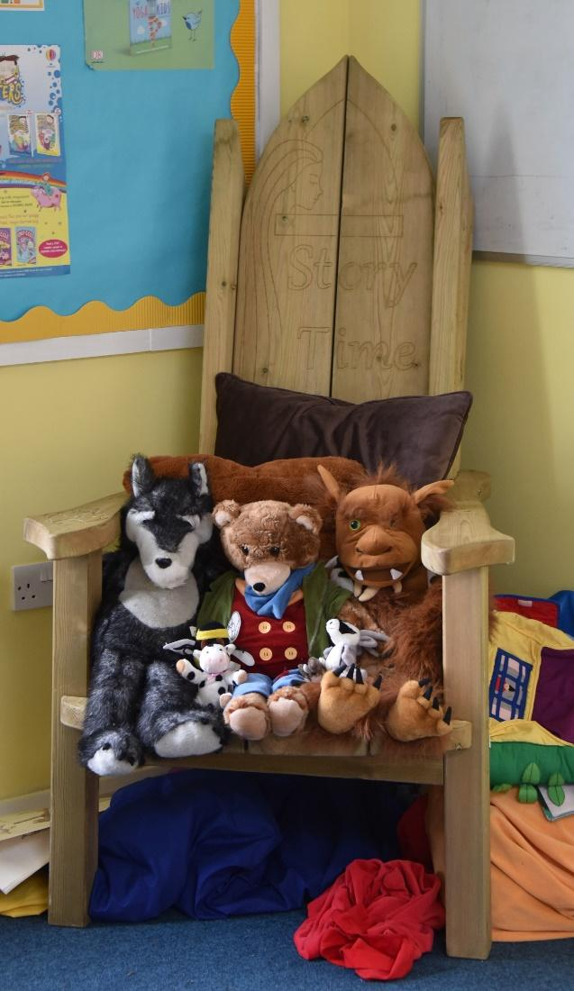
Meetings with the class teacher

There should be plenty of opportunities to speak to your child’s teacher whether in person, at the start or end of the day or on the phone if you are not able to come into school. We are always happy to make arrangements for you to meet with the class teacher if the need arises. In addition, we hold parent consultations during the autumn and spring terms for you to meet your child’s teacher, review your child’s work and discuss progress. An annual report is provided in the summer term giving details of your child’s achievements throughout the year.

Newsletters and Daily Communication

Newsletters will be issued regularly via email and texts for reminders and updates. We encourage you to sign up for electronic communication as it is more efficient, avoids lost letters in book bags and saves paper. If you prefer to receive paper copies please request them via the office. Please ensure that the office has your up to date contact details.

Daily communication between parent/carer and teacher will usually be through the child’s reading record, homework book or verbally at the beginning and end of the school day. Some notices will be displayed on the notice board outside our front entrance.

School Website

Parents/carers are encouraged wherever possible to access the website as often as possible. The address is www.meppershallschool.org.uk

Term Dates and Inset Days

These can be found on the school website www.meppershallacademy.org.uk or are also available from the school office. We will notify you well in advance of school closure dates due to staff training or if any of these dates change.

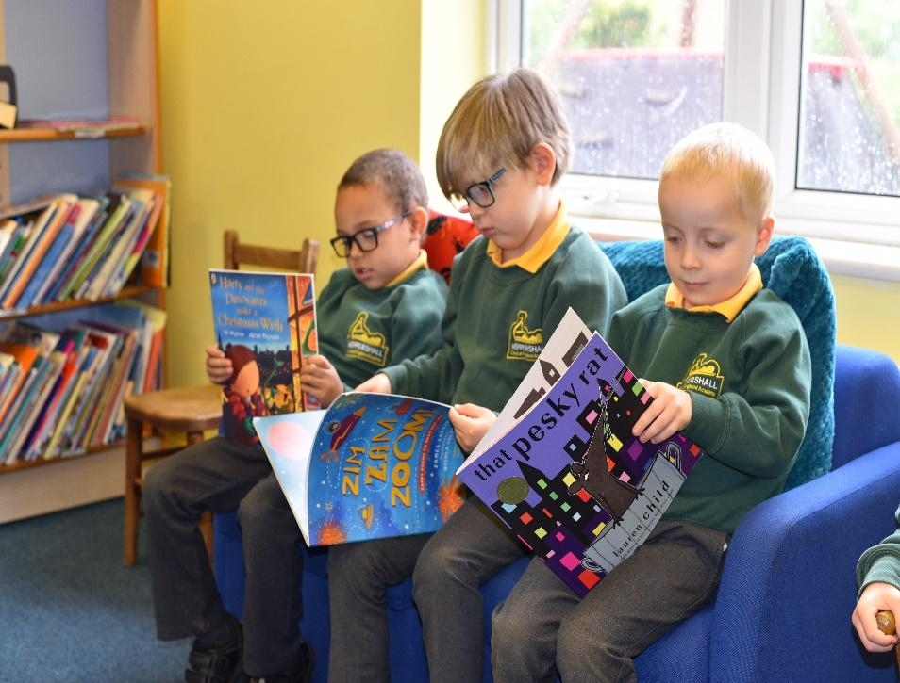

Educational Visits/ School Fund and the Charging Policy

The children will enjoy many educational visits into the local and wider community to support their curriculum learning. They will also benefit from visitors who come to school to share their expertise. Educational visits are an important part of school life and the governors’ charging policy ensures that no child will be prevented from taking part in a visit for financial reasons. Often visits are subsidised but parents/carers may be asked for a voluntary contribution to help pay for expenses such as coach travel. However, activities may have to be cancelled if contributions are not made. Payments can be made via our School Money system. Please make sure you have signed the agreement for local trips in the pack.

Healthy Eating

At Meppershall CE Academy we recognise that good nutrition is essential if our children are to achieve their potential in school and in life. We will aim to enable children and staff to understand the importance of a healthy diet in the context of a healthy lifestyle.

Children in Reception and KS1 will be given a healthy snack at playtime consisting of a piece of fruit or a vegetable in line with the government free fruit and veg scheme. KS2 children are able to bring a piece of fruit or raw vegetables to eat at break time.

We kindly request that children do not bring processed, wrapped snacks as they tend to have high sugar content and leave us with a litter problem. Fresh fruit and veg snacks are the best option.

All children need to bring in a clean, filled, named water bottle every day.

Milk is available free of charge to children aged under 5 years, and is available to purchase thereafter via our Cool Milk scheme. Please contact the office to arrange.

School Meals

The school is committed to providing fresh healthy food each day and offer a balanced and nutritional diet.

School dinners are supplied by The Lunchtime Company, who takes great care to comply with the food and nutritional standards set out by the Government.
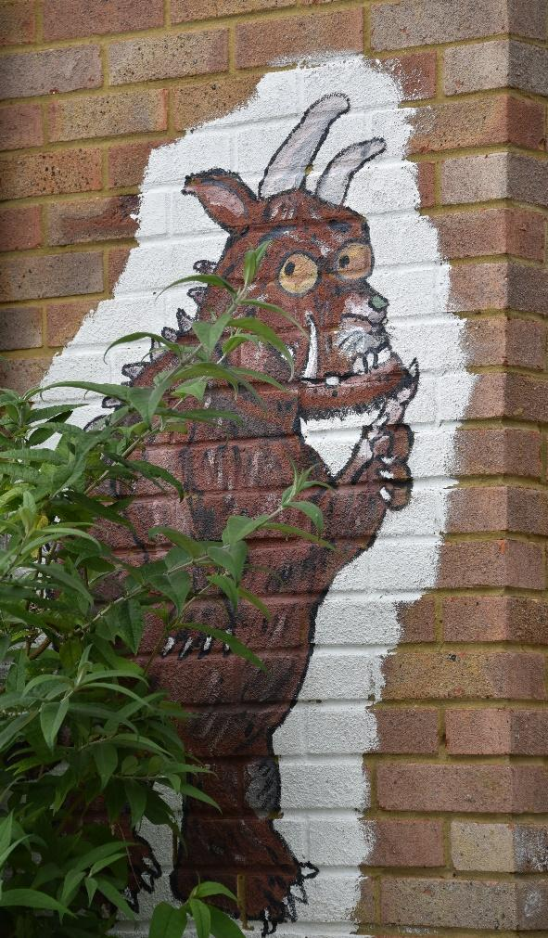

Children will have a choice of a hot meal each day including vegetarian, a school packed lunch or a home packed lunch can be brought in. A copy of the menu will be available on the school noticeboard, from the school office and via email at the beginning of the autumn, spring and summer terms. Children can opt to eat school meals on a specific day(s) or every day. They decide each morning.

Meals are available free until the end of Year 2. For Year 3 and 4 they are currently £2.40. We encourage all children to try the meals and decide which days they would like. Dinner money is to be paid for in advance via School Money.

If your child brings packed lunch to school, it must be in a clean, sealed container, clearly labelled with the child’s name and class. We are a nut free school so please check there are no nuts in what your child brings to school.

Again, because we try to help in reducing sugar intake, we ask you to avoid giving your child chocolate, chocolate covered snacks and sweets. Fruit, yoghurts and plain biscuits may be sent in as a pudding. As every child is offered water at lunchtime there is no need to provide a drink as many squashes and juices contain unnecessary sugar which can lead to tooth decay and obesity later in childhood.

Parking and Site Access for Pedestrians

The safety of everyone coming onto the school site is our priority. The school car park is very small and is for staff only. Clear access is needed by taxis and minibuses dropping off and collecting children. It can be particularly hazardous at these times.

For reasons of safety and because of the taxis and minibuses, parents/carers will be requested not to park on the school premises or use the vehicular access when on foot.

Please do not park on the yellow zig zag lines outside the gates when bringing your child/ren to and from school. Traffic wardens patrol regularly and issue fines to anyone parked on them. When parking nearby please remember to park considerately, respecting our neighbours and other road users at all times.

Pedestrian access to the school is via the small gate ONLY. This is the only permitted pedestrian entrance and exit. By using the vehicular access on foot you are putting yourself and your child/ren at risk of an accident. This entrance and exit is for taxis at either end of the day.

Scooters / Bicycles at school

We do encourage activity as part of a healthy lifestyle so we are keen to see children walking, cycling and scooting to school. Children will be allowed to leave a scooter/ bicycle on the school premises at the owners’ risk. We would encourage them to wear helmets and remain within your line of sight.

School Policies

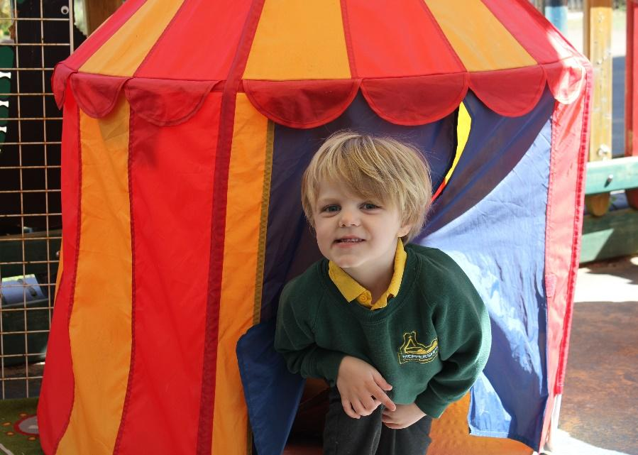
At Meppershall Church of England Academy we believe policies are vitally important, and help us create standards of quality for learning and safety, as well as expectations and accountability. To look at our policies please see our website www.meppershallschool.org.uk and click on ‘Policies’ to read some of our policies.

Meppershall Academy Parent Teacher Association (MAPTA)

All parents/carers and staff will automatically be members of the PTA. The association aims to support the work of the school and to provide opportunities and resources to benefit all children. We have a very active and supportive PTA committee and members are welcome to join and attend regular meetings to organise events. Being on this committee is fun and can be a way of making new friends in a new community, as well as setting up activities for the children, arranging social functions, organising fundraising events and providing a parent

network to support each other. We hope that you will want to involve yourself in the work of MAPTA either on the committee or by giving your assistance when required. Please see the office for further information or the MAPTA notice board which is located outside the school reception area.

Smoking

We have a non-smoking policy in the interests of a healthy environment and to set our children a good example. The school and grounds are designated a NO SMOKING area. We request that you do not smoke whilst on the school premises.

Transfer

Please let us know in writing if you are moving your child to another area, giving details of the address of the new school and date of leaving. School records will be sent to your child’s new school once they are registered there.

Making a Complaint

The Governing Body hope that all the time your child spends at this school will be happy and purposeful. However, if you have any concerns regarding the education of your child the

please talk first to the class teacher, then to the Head of School who will investigate all concerns thoroughly. Should any of your concerns continue then under the terms of the 1988 Education

Act, the Head of School will be able to give you information as to the procedure required to make a formal complaint to the Governing Body.

We do emphasise the need for parents/carers to discuss fully any concerns with the class teacher and the Head teacher before following formal procedures.

Thank you for taking time to read this information. If you have any questions please contact the school office.

Mrs Margaret Newman

Head of School

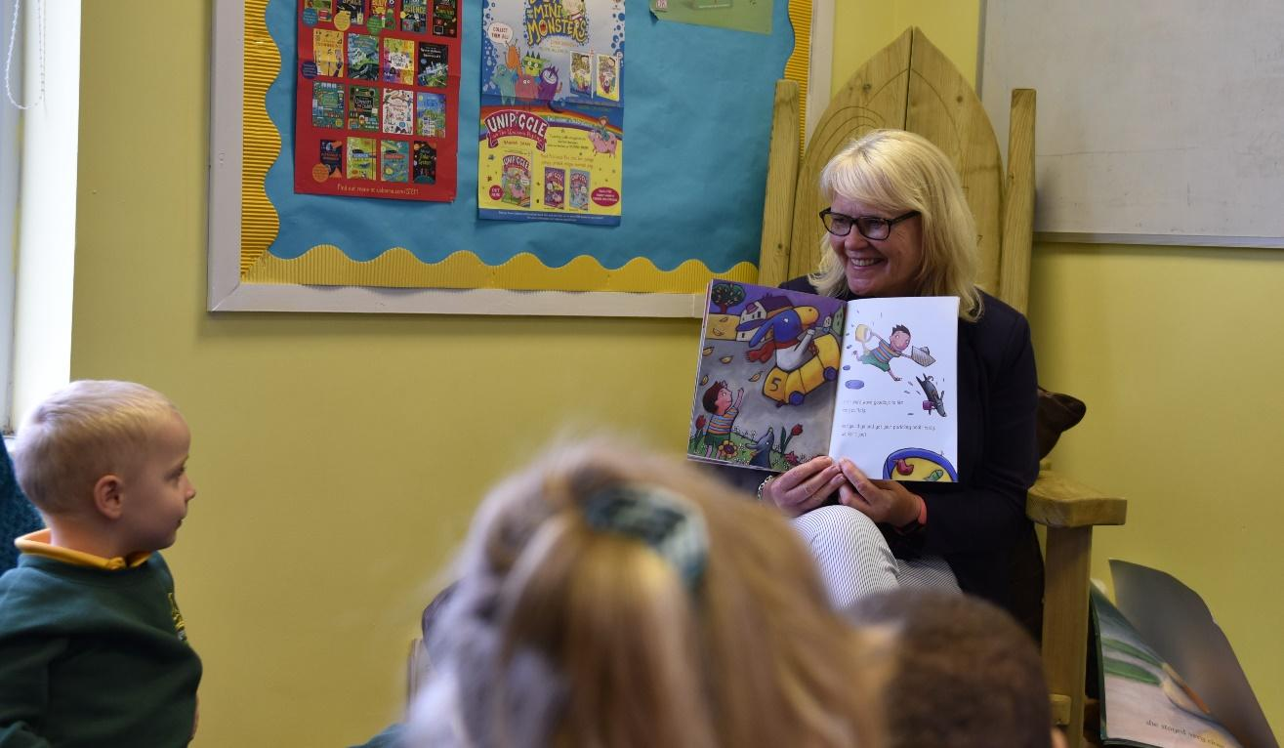
Please keep this booklet handy for future reference. Thank you.

